Heading One

Heading 2

Heading 3

Heading 4
Body text (Normal) Lorem ipsum dolor sit amet, consectetur adipiscing elit. Curabitur et quam ipsum. Nunc sed dolor dolor. Suspendisse sit amet justo a erat luctus pellentesque sit amet sit amet nulla. Nunc vehicula eros hendrerit purus commodo blandit ut vitae est. Proin molestie felis non velit dapibus, sed feugiat
Lorem ipsum dolor sit amet, consectetur adipiscing elit. Curabitur et quam ipsum. Nunc sed dolor dolor. Suspendisse sit amet justo a erat luctus pellentesque sit amet sit amet nulla. Nunc vehicula eros hendrerit purus commodo blandit ut vitae est. Proin molestie felis non velit dapibus, sed feugia.

Numbered list:
- Numbered list item
- Numbered list item level 2
- Numbered list level 3

Alphabetical list:
- Alpha list item
  - Alpha list item level 2
    - Alpha list level 3

Bulleted list:
- Bulleted list item
- Bulleted list item
- Bulleted list item

Step 1
Lorem ipsum dolor sit amet, consectetur adipiscing elit. Curabitur et quam ipsum. Nunc sed dolor dolor. Suspendisse sit amet justo a erat luctus pellentesque sit amet sit amet nulla. Nunc vehicula eros hendrerit purus commodo blandit ut vitae est. Proin molestie felis non velit dapibus, sed feugiat

Table example
COLUMN ONE | COLUMN TWO | COLUMN THREE
1 | Lorem ipsum dolor sit amet, consectetur adipiscing elit. Curabitur et quam ipsum. Nunc sed dolor dolor. Suspendisse sit amet justo a erat luctus pellentesque sit amet sit amet nulla. | Lorem ipsum dolor sit amet, consectetur  adipiscing elit. Curabitur et quam ipsum. Nunc
2 | Lorem ipsum dolor sit amet, consectetur adipiscing elit. Curabitur et quam ipsum. Nunc sed dolor dolor. Suspendisse sit amet justo a erat luctus pellentesque sit amet sit amet nulla. | Lorem ipsum dolor sit amet, consectetur adipiscing elit. Curabitur et quam ipsum. Nunc
3 | Lorem ipsum dolor sit amet, consectetur adipiscing elit. Curabitur et quam ipsum. Nunc sed dolor dolor. Suspendisse sit amet justo a erat luctus pellentesque sit amet sit amet nulla. | Lorem ipsum dolor sit amet, consectetur adipiscing elit. Curabitur et quam ipsum. Nunc

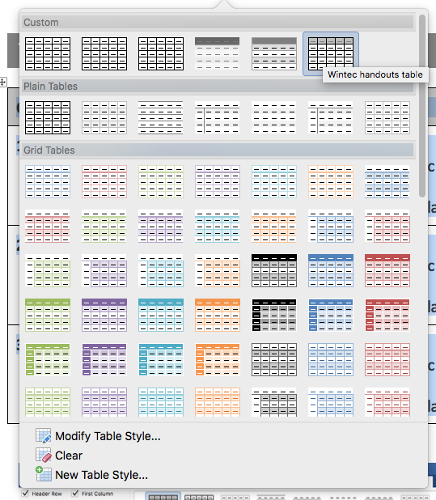
Table style can be found in the custom section of the table design menu – labelled
‘Wintec handouts table’. Use paragraph style ‘Table text’ for text contained in a table.

Table example Module codes
Programme: | Bachelor of Applied IT
Module: | Data Structures and Algorithms
Module code: | COMP605

Due dates: | Week 4 (Test 01)  Week 16 (Test 02)
Weightings: | This assessment is worth 50% of the total module mark.
Assessment Pass criteria: | You must achieve a minimum of 50% average to achieve a passing grade in this assessment.

Table style can be found in the custome section of the table design menu – labelled
‘Module codes’.

Answer text
Lines for answers can be added using the ‘Answer line’ style. Use the enter key to create as many lines as your answer requires. Here’s an example.

Here is a section in landscape
COLUMN ONE | COLUMN TWO | COLUMN THREE
1 | Lorem ipsum dolor sit amet, consectetur adipiscing elit. Curabitur et quam ipsum. Nunc sed dolor dolor. Suspendisse sit amet justo a erat luctus pellentesque sit amet sit amet nulla. | Lorem ipsum dolor sit amet, consectetur  adipiscing elit. Curabitur et quam ipsum. Nunc
2 | Lorem ipsum dolor sit amet, consectetur adipiscing elit. Curabitur et quam ipsum. Nunc sed dolor dolor. Suspendisse sit amet justo a erat luctus pellentesque sit amet sit amet nulla. | Lorem ipsum dolor sit amet, consectetur adipiscing elit. Curabitur et quam ipsum. Nunc
3 | Lorem ipsum dolor sit amet, consectetur adipiscing elit. Curabitur et quam ipsum. Nunc sed dolor dolor. Suspendisse sit amet justo a erat luctus pellentesque sit amet sit amet nulla. | Lorem ipsum dolor sit amet, consectetur adipiscing elit. Curabitur et quam ipsum. Nunc
4 | Lorem ipsum dolor sit amet, consectetur adipiscing elit. Curabitur | Lorem ipsum dolor sit amet, consectetur adipiscing elit. Curabitur
5 | Lorem ipsum dolor sit amet, consectetur adipiscing elit. Curabitur | Lorem ipsum dolor sit amet, consectetur adipiscing elit. Curabitur
6 | Lorem ipsum dolor sit amet, consectetur adipiscing elit. Curabitur | Lorem ipsum dolor sit amet, consectetur adipiscing elit. Curabitur
7 | Lorem ipsum dolor sit amet, consectetur adipiscing elit. Curabitur | Lorem ipsum dolor sit amet, consectetur adipiscing elit. Curabitur

Another Portrait section

Equations
Eqautions have their own style to allow for easy reading.
$T\left(n\right)=2*2T\left(\frac{n}{2*2}\right)+n+n$
Numbered:
- $T\left(n\right)= \left\{\begin{aligned}T\left(n-1\right)+1; n>1 \\ 1 n=1 \end{aligned}\right.$
Listed alphabetically:
- $T\left(n\right)= \left\{\begin{aligned}T\left(n-1\right)+1; n>1 \\ 1 n=1 \end{aligned}\right.$
EQUATIONS IN A TABLES ALSO HAVE THEIR OWN STYLE
$$f\left(n\right)=24n^{2}$$ | $$O(n^{2})$$

