Mind Mapping Techniques

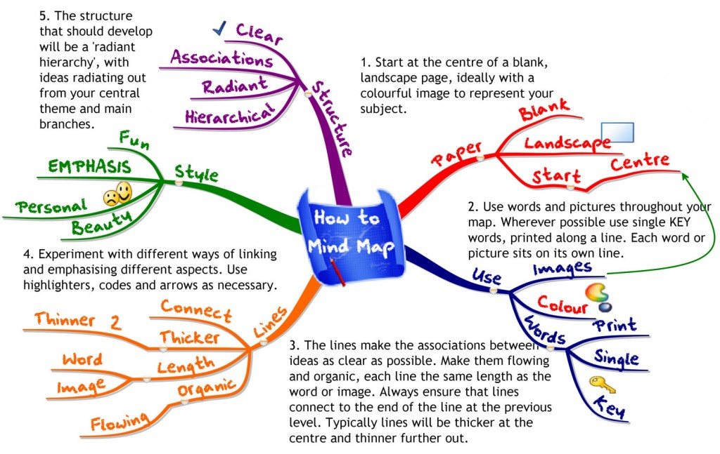
Reference: illumeco.uk

