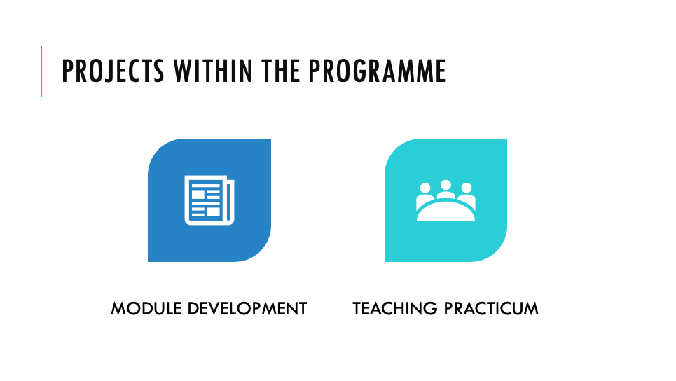

Projects Within the Programme

There are two projects to be completed within this programme
By the end of the 12-week programme each participant will have:
- Planned and facilitated two student-centred micro teaching sessions
- Developed a 150-hour competency-based module.

Teaching practicum | By the end of this programme each participants will have planned and facilitated two micro teaching sessions | Lessons will:  - Be 30 minute, student-centred lessons which reflect aspects covered in the TTT sessions  - Have learning outcomes, activities and assessments which demonstrate constructive alignment  - Include relevant and suitable teaching materials
Teaching practicum |  | Formative feedback and summative assessment will be given.
Module development | By the end of this programme each participant will have modified/developed a 150-hour module. | The developed module will reflect the learning that has occurred throughout the TTT programme, mentoring and industry engagement.
Module development |  | The module developed will include:  - Development of a graduate profile  - Creation of learning outcomes for the module  - Key teaching topics will be defined  - Teaching activities created  - Lesson plans developed  - All assessment activities  - Performance criteria and marking schedules  - Student and peer evaluation tools created
Module development |  | The module will be presented to peers and facilitators of the MP TTT. It will receive formative feedback from peers, mentors and facilitators.

Project One: Module Development

Aim:
Develop or modify a 150-learning hour (15 credit) course that reflects a learner-centred approach to teaching and learning for your teaching context.

Task:
Develop a module package that includes a graduate profile, module descriptor and all teaching, learning and assessment materials.

Guidelines:

- Create a graduate profile for the programme your module sits within (template provided).
- Create a module descriptor for the module you are developing that includes the learning outcomes for your module (template provided).
- Plan activities to facilitate the learning outcomes using the OSTAR template (template provided). This is a tool to ensure constructive alignment.
- Create lesson plans for each teaching session within your module (template provided).
- Design learner-centred assessment tasks and marking criteria to assess your module learning outcomes (template provided).
- Create student and peer evaluation tools to gain feedback on your module.

Marking Criteria: Module Development

Criteria | Comment | Pass/ Incomplete
Graduate Profile
Includes:
- Opening statement outlining the expectations of the qualification.
- Graduate attributes that address three domains of learning.
- Phrased with an appropriate opening verb
- Career pathway describes what types of jobs the graduate will be prepared for.
Module Descriptor
Includes:
- Template is completed.
- Aim statement reflects the purpose of the module.
- Learning outcomes are measurable.
- Learning outcomes are phrased with appropriate opening verbs.
OSTAR template
Includes:
- Learning outcomes for the module are specified.
- Success criteria include what measures will demonstrate students have achieved the learning outcomes.
- Topics within the module are identified.
- Activities to facilitate learning outcomes are planned and described.
- Resources required to facilitate learning are listed.
Lesson plans
Includes:
- Lesson plans are created using the template provided.
- Lesson plans are created for all teaching sessions with the module.
- Lesson plans reflect a learner-centred approach to teaching and learning.
Assessment
Includes:
- Learner-centred assessment tasks are created to assess all module learning outcomes.
- Marking criteria is developed to grade assessment.
Evaluation tool
Includes:
- Course evaluation tools is created.
- Peer evaluation tools are created.

Worksheet Graduate Profile

The opening statement: Begin with a general statement outlining the expectations of the qualification.

Example: On successful completion of this certificate learners will be able to…

Complete opening statement: end the opening statement with a summary of the learner attributes.

Example: … … work well in teams, participate fully in the production process and … …

Graduate attributes: These are descriptive statements of the knowledge, skills and attitudes learners will acquire during their studies. They generally address three generic domains:
- Personal -These describe the personal capabilities, knowledge and skills contextualised to the course of study (work in a team, take leadership, communicate…).
- Domain-specific – These describe the subject-specific competencies, skills and knowledge acquired (Can use specialist equipment, understand safety procedures in confined spaces … …).
- Social – These describe subject-specific attitudes and values acquired (Understands the full breadth of issues surrounding the social, environmental, regulatory and ethical concerns associated with the domain).

Pathway: What the learner will be able to do on completion.

Example: … … will gain skills and experience that will prepare them for careers as … …

Example Graduate Profile Template

Title
Version |  | Qualification type
Level |  | Credits
Outcome Statement | Graduate profile | On successful completion of this module, graduates should be able to…  Summary of graduate attributes:  Graduates should be able to…  Graduate attributes:  - Personal  - Discipline-specific competencies  - Social attributes  Pathway  Graduates will gain skills and experience that will prepare them for careers as … in … departments in …

Example Module Descriptor Template

Headings are used for ease of navigation. Headings also mean you can focus your topic and minimise the information required below.
Module Code and Title
Credit Value | How many credits is the module worth? Work on the formula that 10 learning hours equals 1 credit
Level of Study | Is this entry level (1), fundamental (2-3), intermediate (4-5), advanced (6)
Pre-Requisites | What course(s) should learners undertake to gain the background skills and knowledge to be successful in this course
Co-Requisites | What other courses do learners need to take to compliment the skills they will learn in this course
Directed Hours  Teaching Hours |  | Self-Directed Hours  Learner Hours | Total Student Learning Hours (TSLH)  Total Hours
Aim:
What key skills and knowledge will the learners acquire by taking this module? NB: This should be related to the graduate profile
Learning Outcomes:
- What specific activities will learners engage in to ensure they acquire the skills and knowledge described in the aim.
- etc.
- etc.
Content:
What materials and resources are required for learners to engage in the activities mentioned above
Teaching Learning Methods:
How will learners be engaged e.g. group work, workshops, classroom ... .... .... ...
Assessment Details:
Name | Type | Weighting | Learning Outcome(s) met
e.g. Assessment 1 | Case Study | 40% | Learning outcome 1 and 2

Marking Schedule:
What guides can be provided to ensure there is a consistency in marking
Assessment 1 | Evidence requirements  1.  2.  3 .

Criteria to Pass this Module:
What evidence will the learner provide to demonstrate their competency e.g. marks for an exam, an artefact, a presentation, marks for an essay?
Specific Teaching and Learning Resources:
An extended reading list will be supplied by the tutor at commencement of the module. This will be updated annually.

OSTAR Template

Learning Outcome  (from Module descriptor) | Success Criteria  What you expect students to demonstrate to show LO. | Theme or Topic  What is the theme, topic or context for learning? | Activities  What activities will you provide to build knowledge and skills and enable students to meet LO. | Resources  What resources will you need?

Example Lesson Plan Template

Module code: | Module title: |  |  | Instructor:
Topic: |  |  |  | Date:
Group session: (Taught session/Individual task) |  |  |  | Time:
Learning outcomes:
Classroom Layout / Workshop Space:
Content/Topic |  | Method | Activity |  | Resources | Time
 |  |  |  |  | E.g. Work sheet/video clip/books...
Assessment: (can be formative or summative)

Evaluation: (should be evaluated after each class)
Via group summary at the end of the lesson to ensure successful learning has taken place. Track learning as the lesson goes on by evaluating completion of group and individual tasks. Ask questions along the way to ensure reinforcement of main points. Give students a feedback opportunity/question and answer session at the end.
Reflection: (should be reflected after each class)
Reflect on what I think went well, what students liked based on their feedback and recap of their knowledge at the end of the session. This will help me to think about what I could improve on/use next time to enhance teaching and learning processes.

Project Two:

Micro Teaching Sessions

Facilitated learner-centred session one

For this session you are to:

Select a topic from within your teaching content area or a topic you are familiar with.

Plan and facilitate a 25 to 30 minute session to a small group using the content you have selected.

Ensure that you demonstrate the following adult teaching competencies:

- The physical environment is prepared to take into account learner requirements and delivery methods.

- Content is planned, and materials prepared prior to the start of the session.

- Questioning is used to facilitate interaction and to check and consolidate learning.

- The learning outcomes and sequence of content are explained to learners at the start of the session.

- At least one learner centred activity is included in the lesson.

Following the session, you should seek feedback on the facilitation competencies above. You should also reflect on this feedback and outline any future adjustments you could make to the session.

Facilitated Learner-Centred Session One

Name: Date: ……………………………..
The aim of this session is for you to gain feedback from colleagues/peers. It is important that you annotate the ‘self’ tick box before undertaking the session.

Physical environment | self peer  Appropriate layout of furniture  Awareness of any special requirements | Comments
Content was planned, and all materials were prepared prior | self peer  Written lesson plan  Support material available
Learning outcomes and sequence of content was shared | self peer  Learning outcomes clearly conveyed  Sequence of content explained
Questioning was used | self peer  Open questions are used to promote interaction and consolidate learning  Probing questions are used
At least one learner-centred activity was included | self peer  At least one learner-centred activity was used  Activity was explained clearly to participants

Facilitator reflection: (What will I change? What will I try differently? What feedback did I receive that needs more explanation? Any other relevant thoughts?)

Assessor Comments:

Facilitated Learner-Centred Session Two
In this facilitated learner-centred session you will work with a small group for 30 minutes.

You should ensure that you demonstrate the following adult teaching and learning competencies:

- A formal written session/lesson plan is provided prior to the start of your session.

- The physical environment is prepared to take into account learner requirements.

- Content is planned, and material prepared prior to the start of the session.

- The learning outcomes and sequence of content are explained to the learners.

- At least one learner centred activity is included in the lesson.

- Questioning is used to facilitate interaction and to check and consolidate learning.

- You select and use educational media to support the achievement of your learning outcomes as appropriate.

- You model adult teaching and learning principles.

Facilitated Learner-Centred session two
Name: Date: ……………………………..
Criteria for Session | Standard | Comments
Preparation:  - formal written session/lesson plan is provided  - physical learning environment is set up appropriately | Session/lesson plan contains all required components. All materials are prepared in advance. Appropriate layout of furniture.
Start of session demonstrates:  - clear and relevant learning outcome(s) and sequence of content being shared, (including method of motivating students) | SMART Learning Outcome(s) have been created. Topic is clearly outlined, and sequence is explained.
Body of session demonstrates:  - content follows steps.  - at least one learner-centred activity is demonstrated  - appropriate educational media are selected and used to aid learning  - suitable questioning | Learner-centred activity facilitated where learners are participating, collaborating, and interacting with each other, rather than the facilitator.  Activity clearly supports achievement of the learning outcome(s). Educational media is constructively used to support the session.
Conclusion  - Main points are reviewed | Learner-centred recap is used to check that learning has happened.
Facilitator demonstrates:  - adult teaching and learning principles  - questioning and listening skills  - clear explanation of skills/knowledge | Learner-centred learning and adult learning theories are evident in the lesson plan and teaching practice session. Evidence of questioning, listening, probing, clear explanation of learning being undertaken.
General Comments:

Pass / Incomplete Assessor: ………………………….…….….…

Facilitated Learner-Centred session guidelines
Qualities of Lesson | Guidelines
Preparation | A comprehensive session/lesson plan must be supplied which includes:  - correctly worded and appropriate learning outcomes  - the planned sequence of learning activities  - the delivery strategies  - the resources required (including educational media) for each segment of the lesson  - the time planned for each segment of the lesson  - evaluation strategies
Materials prepared in advance | You must have:  - all materials prepared and ready for use
Physical learning environment set up appropriately | You must ensure the following when setting up the physical environment:  - an appropriate layout of furniture  - optimal viewing conditions for any educational media used
Introduction | You must:
Topic clearly outlined | - clearly convey the topic area and a general outline of the session
Method of motivating students | - come across as being interested in the material you are covering – consider techniques such as model(s), a short warm up/ice-breaker, relevant game, a story or anecdote, samples of completed work, visuals or a key question to motivate and interest the group
Learning outcomes are clear, relevant for the level of the students and are achievable within the timeframe of the lesson | - write correctly worded SMART learning outcomes that are realistic and achievable  - clearly convey the learning outcomes to the learner group
Body of lesson | You must:
Content follows steps | - plan a series of learning activities that follow a clear and logical sequence
Appropriate educational media are selected and used to aid learning | - use at least one form of educational media  - ensure that the material conveyed by media is relevant to the learning outcomes of the session  - demonstrate competence in the use of the media to ensure basic rules of legibility and readability are met
At least one student-centred activity is incorporated | - include at least one student-centred activity in the lesson, examples of student-centred activities include group or pair activity, application of a practical skill that has been demonstrated, short case study/ scenario analysis, individual work, matching activity.
Conclusion | You must
Main points are reviewed | - review the key points of the lesson at the end, techniques that can be used to review include asking a series of key questions, going back to the learning outcomes, getting the students to write down the key points individually or summarising with the learner group on the whiteboard.
Qualities | Consider the following:
Questioning skills demonstrated | Use of a combination of open/closed and starter/probing questions to check understanding, promote interaction and consolidate learning.
Listening skills demonstrated | Demonstrate listening through the acknowledgement of learner input by such techniques as verbal acknowledgement, paraphrasing or use of body language.
Facilitator’s language is appropriate to subject and students | Use language and explanations that the learner group can relate to.
Facilitator gives clear explanation of skill/knowledge to be taught | Explanation of terminology and/or technical terms that are used. Clear and concise instructions are shared and repeated as necessary.
Models adult teaching and learning principles | Some examples of demonstrating the use of adult learning principles might include:  - working with learner group and acknowledging and building on the past experiences of the students.  - explaining the rationale for an area of content in order to satisfy adults’ need to know why they are learning something.  - enabling the learners to determine their own learning needs.  - supporting learners to work collaboratively with others.  - encouraging mutual planning between learners and with facilitator.  - helping and/or encouraging learners to design their learning outcomes.  - supporting learners to evaluate their own learning.  - fostering critical reflection
Provides a safe and friendly environment for students | - demonstrate awareness of physical, cultural and/or emotional safety appropriate to the group and the topic  - promote mutual respect
A positive relationship with students is established | - establish a positive relationship with the learner group through techniques such as the use of humour, acknowledgement of student input  - display interest in both the content being delivered and the teaching/learning process  - be able to be clearly heard by all the learners  - give concise clear instructions  - repeat and/or adjust instructions where necessary  - exhibit open and inviting body language  - sit down with the students where appropriate  - relate to students’ background through such techniques as questioning and use of real life examples and anecdotes  - (eg. Is this issue relevant for any of you in your work? What do you think about…?  - Has anyone experienced this before? Tell us about it.)  - teach in a non-sexist and non-racist manner at all times during the session  - be inclusive in language and beware of sexist or racist ‘humour’

Notes:

