Teacher-Centred

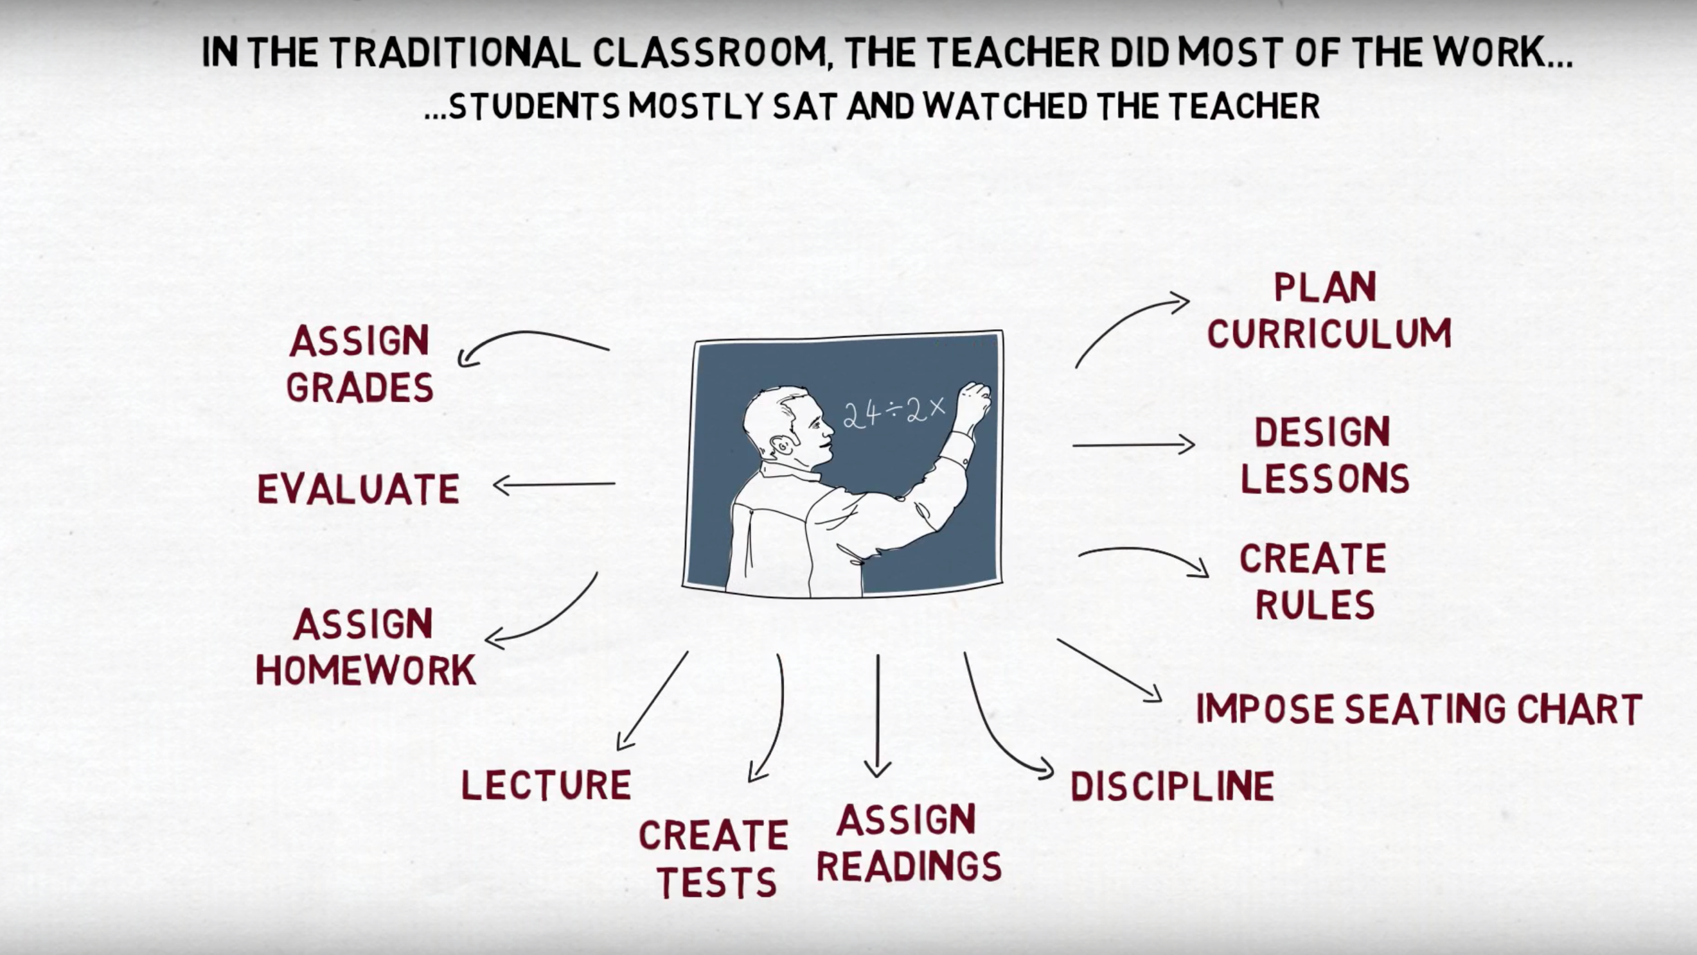

Student-Centred or Learner-Centred

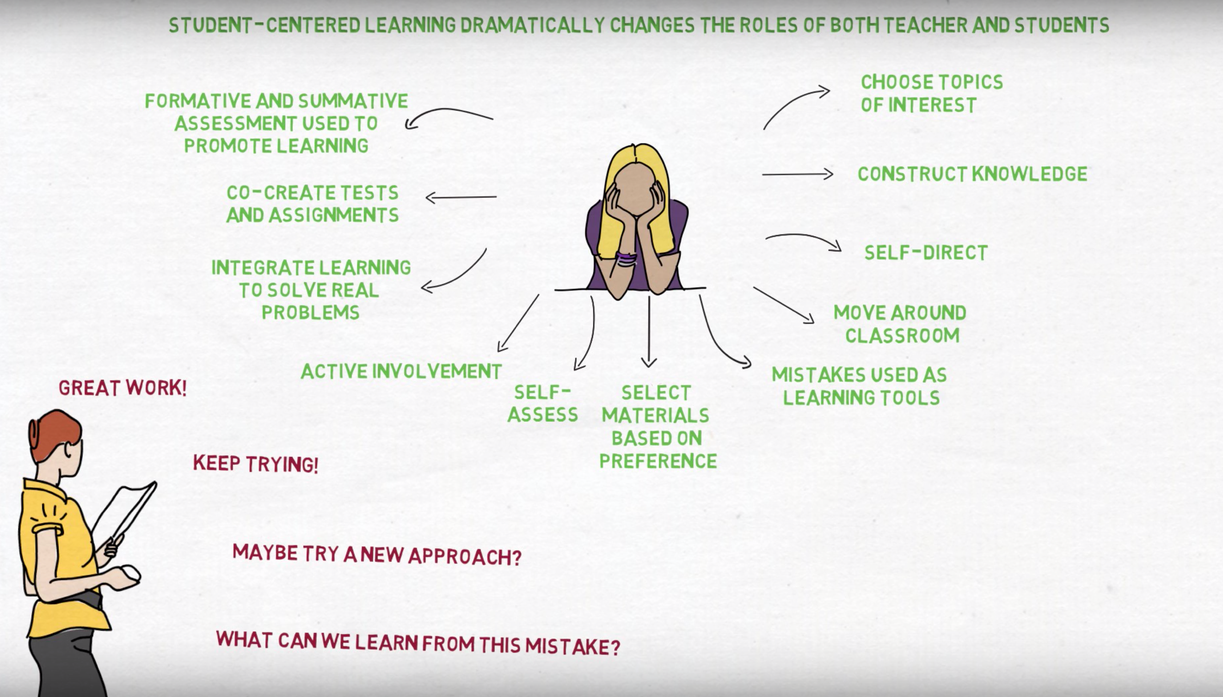

Images: OReilly, J. (2015). Student centred learning. Retrieved from https://www.youtube.com/watch?v=I09uSOHAgP4

