Office 365 Software Download
While you are a student at Wintec you have access to a full suite of Microsoft Office products to help you study. You can use the online versions or download the software onto your own computer. This is available by clicking the Office 365 link form MyLearning.

Office 365
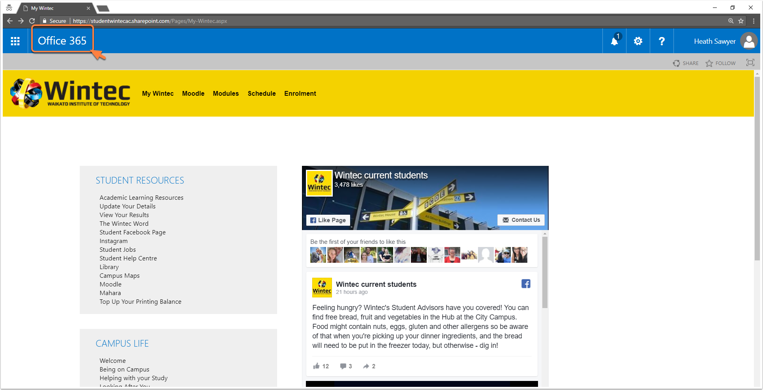

Apps, Software and Documents
1. Use Office 365 online using Apps. You can use these apps from your digital device also by downloading from your App Store and linking your account.
2. Install the Office Apps onto your own computer.
3. Access your One Drive files
